 | Bai Yuna  Fresh graduate of MBA Can start work immediately
  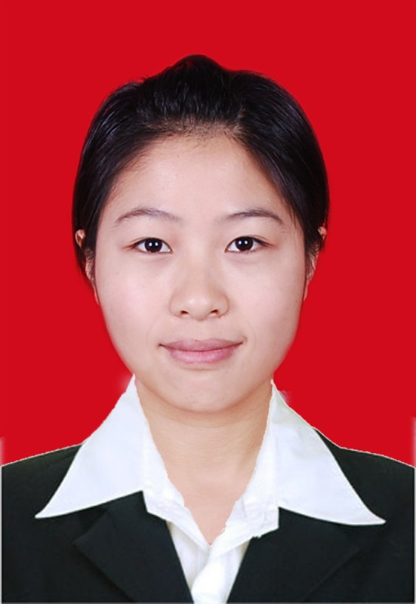
  Expected Salary:
  MYR 2,500
 | (+60) 0173202004 | byn3658@163.com | 26 years old | Negeri Sembilan (Malaysia)
 | Previous | Sales Manager  Shang Hai Li Du Hardware Co., LTD
Customer Service
Shanghai Hilton Hotel
 | Education | INTI International University College (INTI-UC)  Master, Business/ Management (Dec 2013)
 | Nationality | China
 | PR | Malaysia

Experience
Aug 2011 - Apr 2012  (8 months ) | Sales Manager  Shang Hai Li Du Hardware Co., LTD | China
 | Monthly Salary | CNY 3,000
Responsibilities:
-Develop market in a new city -Xiamen
-Take the lead role in selling hardware products to construction site
-Visit at least one construction site every day, find the manager of the purchase department or the power-holder of the architectural products purchasing
-Contract closely with the head office in Shanghai to report the clients' needs and consult professional sale skills and the professional knowledge from department of technology
Experiences Gained:
-Experience in selling intangible products in Architectural service industry
-Experience in communicating with clients and found that
-Get the skill of using internet, software applications including PowerPoint, Word, Excellent oral and written communication skills and knowledge of architectural technology
Jan 2011 - Jul 2011  (6 months ) | Customer Service  Shanghai Hilton Hotel | China
 | Monthly Salary | CNY 2,000
Chinese Restaurant Waitress & Housekeeping Service
Chinese Restaurant Waitress:
-Working in the Chinese Restaurant Department of the hotel
-Waitress role
Housekeeping Service
-Working in the housekeeping Department
-Housekeeping service role, do the work of making up the guest room
Education
Dec 2013 | INTI International University College (INTI-UC)  Master's Degree in Business Studies/Administration/Management | Malaysia
 | Major | MBA (Human Resource)
 | Courses Completed | Finance & Accounting, Economics, Strategy Human Resource Management, Organization Development and Change (HR), Operation Management, Management Organization, Strategy Management, Marketing Management, Business Ethics and Law, Management Information System, SPSS ( Statistical Package for Social Sciences) Business Research Methodology, Project
Skills
Basic | Tour Guide
Languages
Proficiency level: 0 - Poor, 10 - Excellent
Language | Spoken Written Relevant Certificates
Chinese (Primary) | 9 9 -
English | 7 7 IELTS - 6.5
Additional Info
Expected Salary | S$ 2,700
Preferred Work Location | Anywhere in Singapore
Other Information
EDUCATION BACKGROUND:
-Highest education: INTI International University (MBA Program) (In Nilai, Malaysia)
-Bachelor Degree: Henan university (Tourism English) (In Kai Feng, China)
CERTIFICATE:
-Tour guide certificate (IN China)
-CET-6 of Public English Test (IN China)
-IELTS: 5.5
ADDITIONAL INFORMATION:
-Strong sense of responsibility
-Strong Teamwork spirit
-Excelling in interpersonal communication
-With strong affinity
-Strong concept of time, seldom late
-Easy to talk with stranger
-Positive and strong mind to learn and hard working
-Positive to take part in any kinds of activities

